Group Project Proposal

**Functionalities:**

1. Menu bar for useful buttons such as.
   1. Import data
   2. Save project
   3. Load project
   4. Select Colors
   5. Undo / Redo
   6. Optimization Drop Down
      1. Optimization buttons
   7. Other
2. Shortcut buttons
   1. Shift Coordinate
   2. Dominant rectangle searching
      1. Compute Confusion matrix, precision, and recall
   3. Data reduction to Optimal N gon (minimum 4 – gon)
   4. Display Generated Rules (calculate rules)
   5. Disable and enable attributes (canvas updates)
   6. Draw rectangle option

**Suggestions for Functionalities**

1. Use OpenGL and C to create all visual aspects such as buttons and regions
2. Better visualize the dominant rectangles, user has a choice to define their own colors and contrast / blinking. We choose a default that looks best to us.
3. Let the user click and drag the dominant rectangle to better optimize the results.
4. Automatically draw rectangles based on an algorithm. Let user draw their own rectangles and display comparison of accuracy.
5. If a user decides to not automatically draw the rectangles they can draw their own and automatically optimize it with a button.
6. Use disable and enable attributes button to allow the user to find the optimal attributes.
   1. Have an optimization button to find the optimal attributes automatically
7. Menu bar for standard menus such as file and edit, plus any additional menus for similar buttons. Independent buttons (standalone buttons) will be in the shortcut button panel.
8. User has option to do tasks automatically or manually.

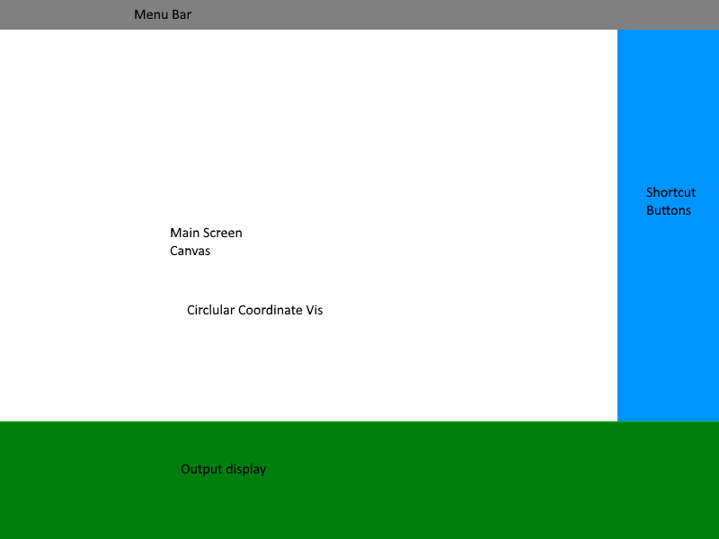Potential Layout of the GUI.